**Cairo University**

**Faculty of Computers and Artificial Intelligence**

# Final Exam

**Department: Computer Science – Software Engineering Undergrad Program**

**Course Title: Software Architecture and Design**

**Course Code: CS 355**

**Semester: Fall 2020**

**Instructor: Dr Soha Makady**

**Date: Feb. 28th, 2021**

**Exam Duration: 2 Hours**

|  |  |  |  |  |  |  |  |  |  |  |  |  |  |  |  |  |  |  |  |  |  |  |  |  |  |  |  |  |  |  |  |  |  |  |  |  |  |  |  |  |
| --- | --- | --- | --- | --- | --- | --- | --- | --- | --- | --- | --- | --- | --- | --- | --- | --- | --- | --- | --- | --- | --- | --- | --- | --- | --- | --- | --- | --- | --- | --- | --- | --- | --- | --- | --- | --- | --- | --- | --- | --- |
| |  | | --- | | تعليمات هامة   * حيازة التيلفون المحمول مفتوحا داخل لجنة الأمتحان يعتبر حالة غش تستوجب العقاب وإذا كان ضرورى الدخول بالمحمول فيوضع مغلق فى الحقائب . * لا يسمح بدخول سماعة الأذن أو البلوتوث. * لايسمح بدخول أي كتب أو ملازم أو أوراق داخل اللجنة والمخالفة تعتبر حال ة غش. | | |  |  |  | | --- | --- | --- | | **Question** | **Mark** | **Signature** | | One |  |  | | Two |  |  | | Three |  |  | | Four |  |  | | Five |  |  | | Six |  |  | | Seven |  |  | | Eight |  |  | | Nine |  |  | | Ten |  |  | | Total Marks |  |  | |  |  | |
| |  | | --- | | **60** | |

**Total Marks in Writing:**

**This exam is a CLOSED book exam.**

**The exam comes in 8 pages (including the cover page).**

## Question 1 [9 marks]

1. Among the object-oriented principles discussed in the course, was “Code to an interface rather than to an implementation”. **Give an example** to illustrate that principle. Your example needs to show how you code to an implementation versus how you code to an interface **[4]**.

1. Explain the difference between prescriptive architecture and descriptive architecture **[2]**.

A system’s prescriptive architecture captures the design decisions made prior to the system’s construction It is the as-conceived or as-intended architecture

A system’s descriptive architecture describes how the system has been built It is the as-implemented or as-realized architecture

1. Explain the difference between software architecture and software design **[2]**.

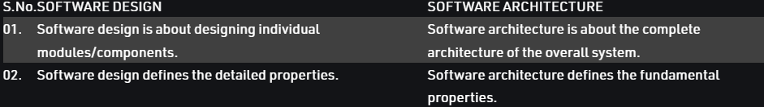

1. Provide **an example** for a decision that would be classified as non-architectural design decisions **[1]**

The system should be able to send and receive messages (or any functional requirement)

## Question 2 [4 marks]

Categorize each of the following requirements **according to the sub-categories** of nonfunctional requirements explained within the course. You must provide a written explanation for your answer. ***If no explanation is provided, no mark will be given for the corresponding part.***

1. The system must use the existing Apache Tomcat web server and use Java Server Pages (JSP) technology to process web requests. __Deployment__

1. For the FCI’s new e-com system, students should know about 90% of the provided features after using the system for 3 full days. __Usability______

Because to make user able to know 90% of features after using system in 3 days requires ease of use and making system easy to be understood.

1. For the FCI’s new e-com system, one student should not be able to view the grades of another student. _Authorization_

1. Fawry electronic payment for mobile phone bills of Etisalat should support 3000 payments per second all over Egypt. _Request load__

## Question 3 [12 marks ]

(a) **[4 marks]** Consider the following source code:

**public class Product {**

**String name; public void setName(String name) { this.name = name;**

**}**

**public String getName() { return name;**

**}**

**//Save to database code.**

**public void Save(){ //Open db connection.**

**//Make some logic.**

**//DB SAVE operation. //Close connection.**

**}**

**}**

1. Which design principle is violated in the code above? You **must** justify your answer by an explanation.

Single responsibility principle as it is the model and the entity classes at the same time

1. Modify that source code to properly apply the violated principle. You need to rewrite the complete source code.

**public class Product {**

**String name;**

**ProductModel product;**

**public void setName(String name) { this.name = name;**

**}**

**public String getName() { return name;**

**}**

**}**

**public class ProductModel {**

**String name; public void**

**//Save to database code.**

**public void Save(){ //Open db connection.**

**//Make some logic.**

**//DB SAVE operation. //Close connection.**

**}**

**}**

(b) [**8 marks**] Consider that you are required to design a software system to display and print shapes from a database. The type of resolution to use to display and print the shapes depends on the hardware configuration of the computer on which the software system is running. If the computer has **low configuration**, the software system should use a **low**-resolution display driver (**L**RDD) to display the shapes and a **low**-resolution print driver (**L**RPD) to print the shapes. If the computer has a **high configuration**, the software system should use a **high**configuration display driver (**H**RDD) to display the shapes and a **high**-resolution print driver (**H**RPD) to print the shapes. **Sketch** a class diagram for the software system while **using the abstract factory design pattern** and **explain** your solution. The diagram should clearly show the attributes/operations/relationships as applicable.

## Question 4 [12 marks ]

Consider Eclipse IDE (integrated development environment) that you usually use to develop your Java projects within programming courses. Such IDE provides several different views for the same file. For example, if you open your Java project “Sprint 1” within Eclipse IDE, you will find the file “Customer.java” represented within the **Project view**, and within the **Inheritance hierarchy view**, and within the **FileInfoView**. If you rename of file “Customer.java” to “User.java”, those three views should reflect the renaming of that file, and how the new file name instead. Furthermore, the ProjectView allows creating Java files and Java packages. However, a Java package can contain Java files, Java packages, or a combination of both. **Sketch one** class diagram to model the above-explained features of Eclipse IDE after applying the needed design pattern(s). The diagram should clearly show the attributes/operations/relationships as needed. **Justify** why you selected each pattern(s).

## Question 5 [14 marks]

Talabaty is an online food ordering website. Talabaty allows **customers** to search for restaurants or browse existing restaurants. However, for the searching feature to work properly, the searching needs to retrieve the complete restaurant information from a restaurants repository that holds all the information of the different restaurants that have a written agreement with Talabaty to be part of their system. Customers are also allowed to add several meals to their meal order. For the meal ordering process to succeed, the meal ordering process demands validating the customer’s credit cards through a third-party (ready-made component). Talabaty **employees** should be able to add/remove restaurants, to add/remove offers for different restaurants to the restaurants repository, to update resturants’ information, and to identify which restaurant are part of current customers’ meal orders. To identify the restaurants that are parts of existing orders, the identification needs to retrieve orders information from an orders repository that holds all the current/past meal orders. Customers can make their orders through Talabaty mobile application, or through a web-based browser.

1. **[6 marks]** Create a component diagram showing the main components of the above system. Your diagram should show the components, and the component interfaces as well using the UML notations.

1. **[2 marks]** For **one component** from part (a), you need to **mention** the services that it provides and **provide** their corresponding APIs.

1. **[6 marks]** Create a deployment diagram for the above system. Your diagram should utilize information from part (a) as needed to completely reflect the describe system while using the UML notations.

**Question 6 [9 marks]** (a) Consider the below figure.

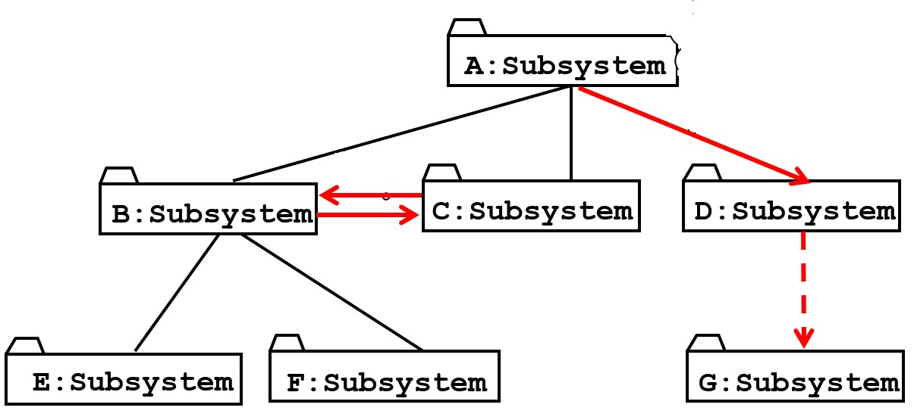

* 1. Within the lectures, the concepts of layer and partition were explained. Explain how those two concepts fit within the above diagram **[2]**.

Each layer is calling the one below only and only the subsystems in the same layer(partitions) can call services from each other.

* 1. Explain the relationships that can exist between layers, while giving an example for each

**[3]**.

Layer A “depends on” Layer B (compile time

dependency)

• Example: Build dependencies (make, ant, maven)

– Layer A “calls” Layer B (runtime dependency)

• Example: A web browser calls a web server

• Partition relationship

– The subsystems have mutual knowledge about each other

• A calls services in B; B calls services in A (Peer-to-Peer)

(b) Consider the following architectural view for some system.

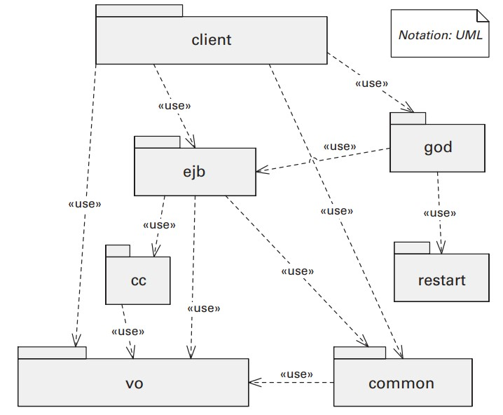

1. Using plain English words, explain this view. Your explanation needs to cover all of the notations used within the diagram **[2]**.

Module structure (uses ) . Notations are components (structures) and dashed lines which shows dependency of components on each other .

1. Use the above view to explain the order in which the developers can proceed with incremental development of that system. You need to mention the exact flow of incremental development **[2]**

Vo must be implemented first also restart can be implemented concurrently , then cc and common , then ejb then god then client .

**End of Exam**